 | Assignment No. 02  Semester: Fall 2022 CS610: Computer Networks | Total Marks: 20  Due Date: 24th January, 2023
Instructions:
Please read the following instructions carefully before submitting assignment:
You need to use MS Word document to prepare and submit the assignment solution on VU-LMS. It should be clear that your assignment will not get any credit if:

- The assignment is submitted after due date.
- The submitted assignment is not in the required format (doc or docx).
- The submitted assignment does not open or file is corrupt.
- The submitted Assignment is copied (partial or full) from any source (websites, forums, students etc.).

Objectives:

To enhance the learning capabilities of the students about:
- Classes of IP address
- CIDR notation and Sub-netting
- Classless addressing

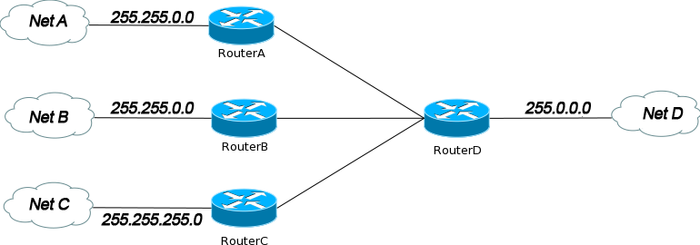Assignment
Question No.1

Given above is a network diagram showing four networks. You are required to find out the class and total number of usable hosts for network associated with Net A , Net C and Net D by assuming class full addressing and provide your answer in the given table:

Network | Class | No. of usable hosts
Net A | B | 65,534
Net C | C | 254
Net D | A | 16,777,214

Question No.2

Following table contains different IP addresses along with their respective custom subnet masks. You are required to find the CIDR notation and total number of subnets per network in the given table:

IP addresses | Custom Subnet Mask of given IP | CIDR  notation  /CIDR Length | Total no of subnets per network
112.8.0.3 | 255.254.0.0 | 112.8.0.3/15 | 128
189.2.0.2 | 255.255.255.0 | 189.2.0.2/24 | 256
196.12.1.0 | 255.255.255.224 | 196.12.1.0/27 | 8
210.15.10.0 | 255.255.255.248 | 210.15.10.0/29 | 32

Best of Luck!

